# **Screenshots of Leaflet Map**

Satellite view of the Map with Earthquake layer:

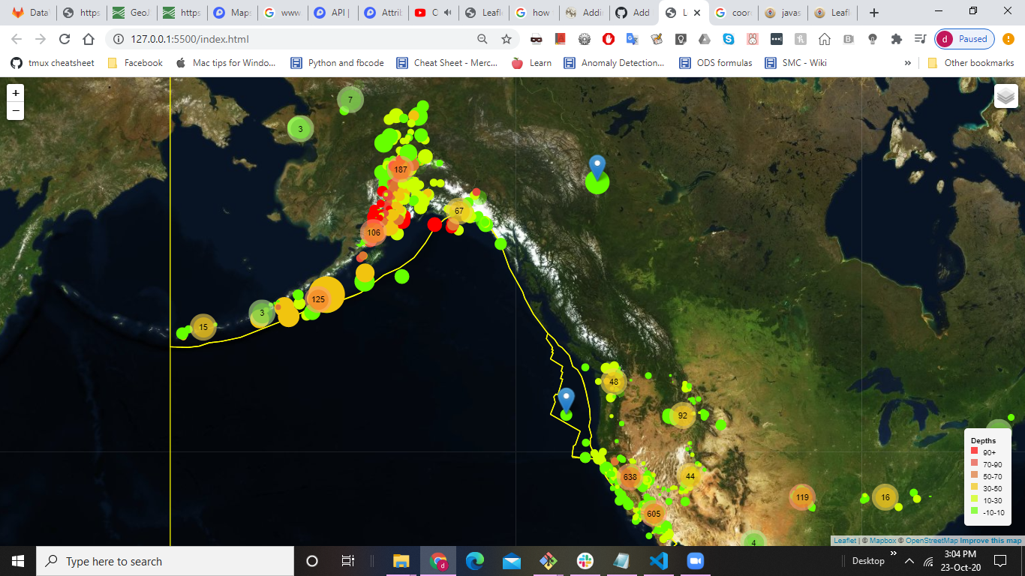

The map has Marker Clusters.Upon clicking each clusters,the map will be zoomed in towards specific markers.Upm clicking them,the tooltip will be visible.

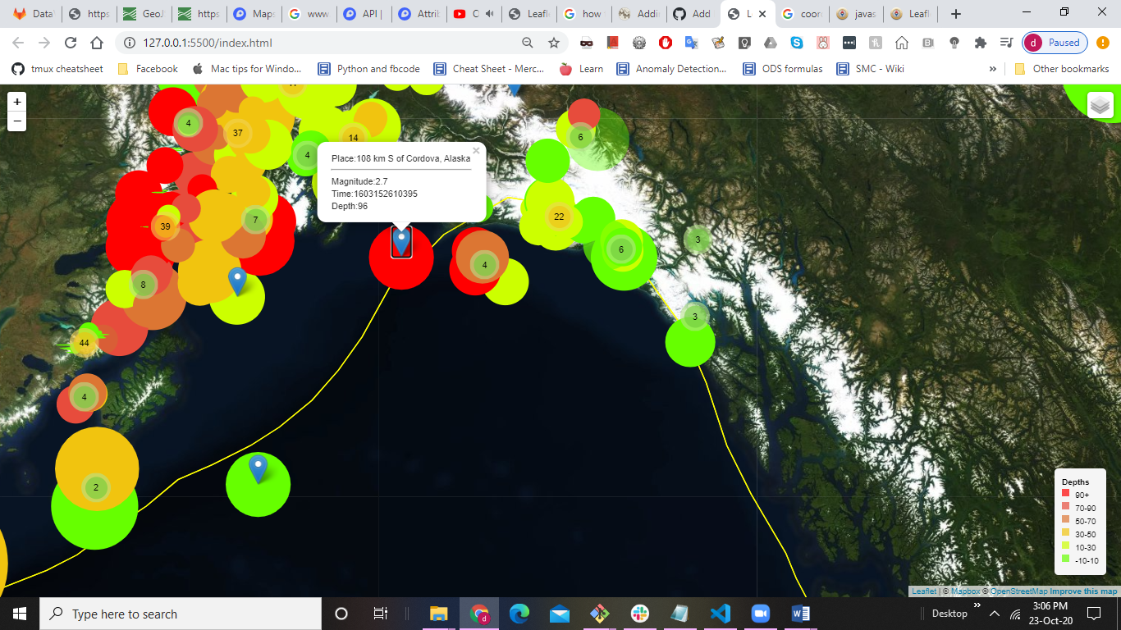

There are different views of the Map, Satellite, Grayscale and Outdoors. We can select the layers.

Then we have 2 data sets Earthquake for the past 7 days and Tectonic plates. We can select them both together or independently as we want.

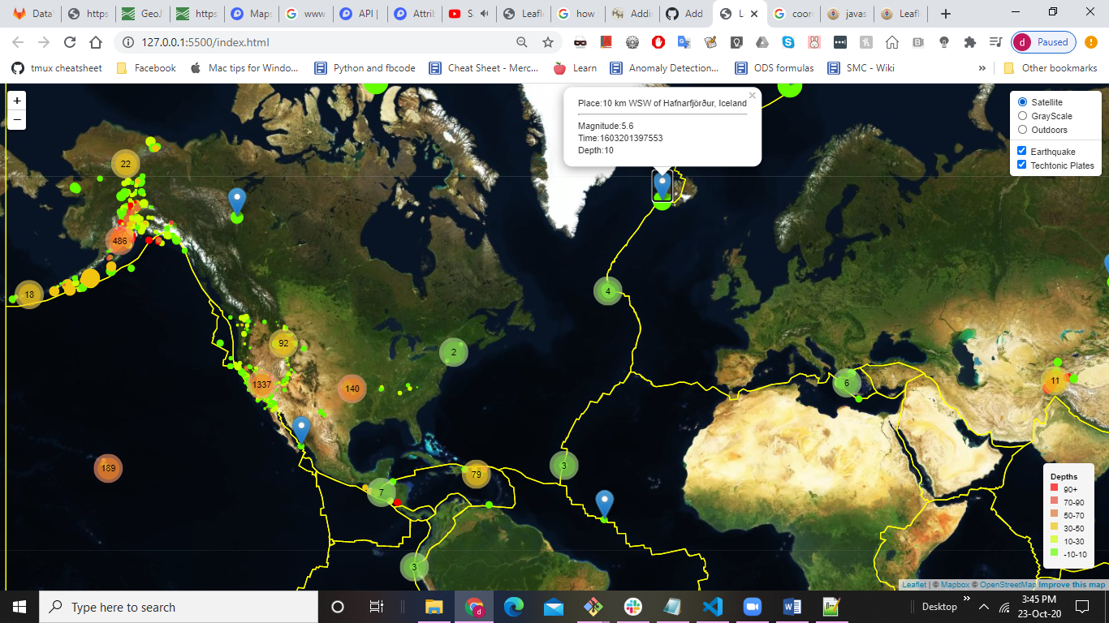

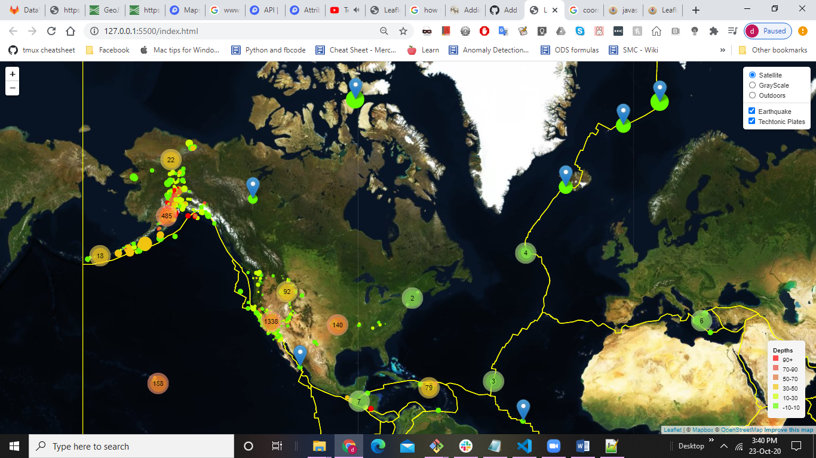

This is the Gray Scale View.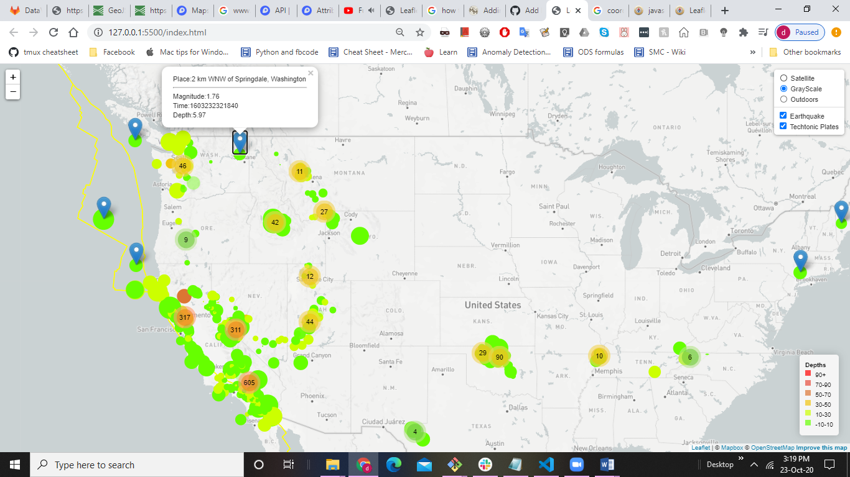

This is the Outdoors View.

